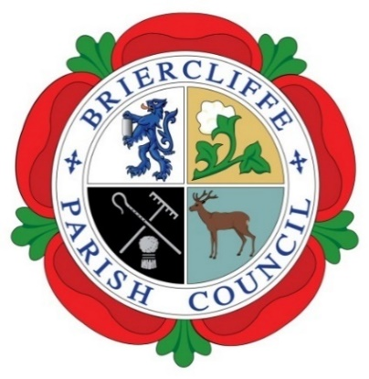
Briercliffe with Extwistle Parish Council

Annual Parish Meeting.

Thursday 30th May 2024 7.30pm

Present: Councillors Roger Frost (Chair), Vicky Balmer, Michael Greenwood, Gordon Lishman, Pippa Lishman, John Marlow, Michael McFarlane, and Richard Sagar.

In Attendance: County Councillor Townley, Borough Councillor M Lishman, R Greenwood (Temp Clerk), plus 2 residents.

The Chair opened the Parish Council Meeting and welcomed all to the meeting.
Annual Parish Agenda | Actions by Clerk | Cllr Support
23/24/105 Announcements

The Meeting was advised that it would be audio recorded for accuracy of the Minutes and training and development purposes only.

23/24/106 Apologies for absence

Apologies were received and accepted from Cllr L Lalor

23/24/107 Declarations of Disclosable Pecuniary Interest

All Councillors present completed and signed their Declaration of Disclosable Pecuniary Interest Forms and returned these to the temporary Clerk.

23/24/108 Chair’s Report for the year.

The Chair, Cllr Frost, presented his report for the year.
23/24/109 Finance Report
The finance report was presented. Outlining the Parish Councils position for the bank, the use of the accounting package Scribe and the income and expenditure of the Parish Council.
23/24/110 Minutes of the meeting held Tuesday 16th May 2023

The minutes of the meeting held Tuesday 16th May 2023 was signed as a true record.
23/24/111 Annual Statement of Accounts and AGAR
A statement from the accounts package, Scribe, accompanied the AGAR form. The AGAR, the bank reconciliation, the variances proforma and the Public Rights notice were reviewed prior to going to Internal Audit
23/24/112 Date of Next Annual Meeting
The date of the next Annual meeting will be Thursday 8th May 2025

